# Steps for Create Power BI Subscription

## Sign up for the Power BI Account

If you don't have a Power BI account, [sign up for a free Power BI Pro trial](https://app.powerbi.com/signupredirect?pbi_source=web) before you begin.

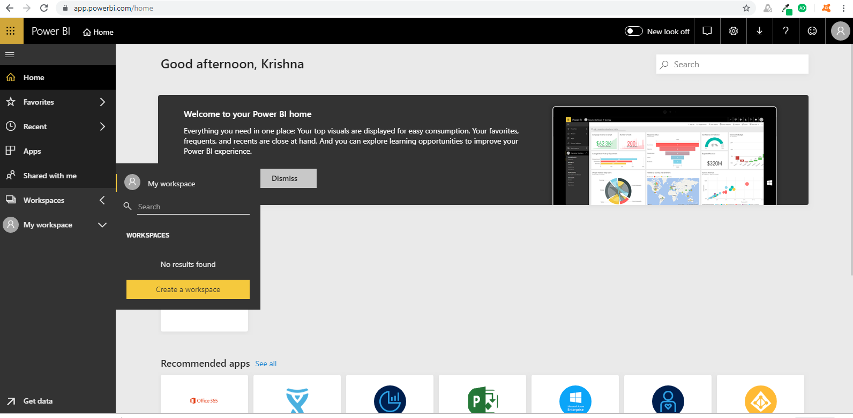

Once Click on Create a workspace button, it will show popup that “**Upgrade to Power BI Pro / Try Pro for free**”.

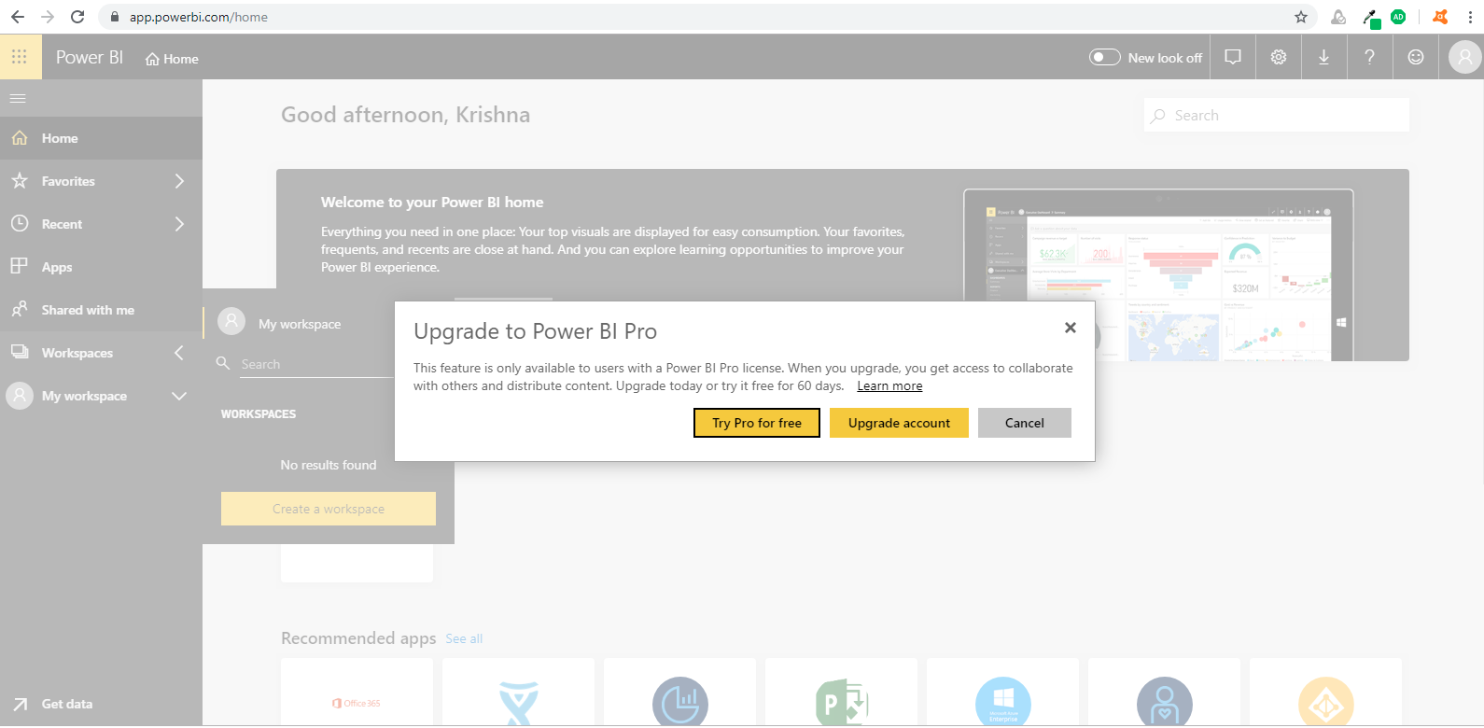

If Select Try Pro for free , you can access Power Bi Pro features extended free for 60 days.

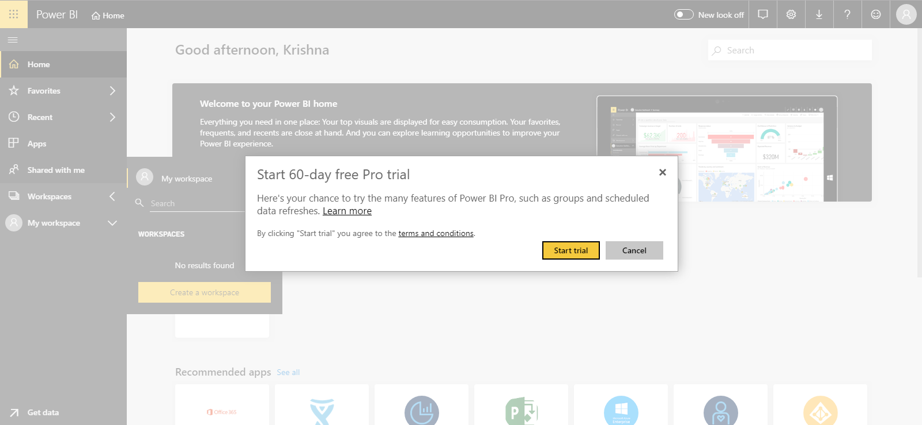

Once Click on Start trial button , it will proceed to success trial extended window.

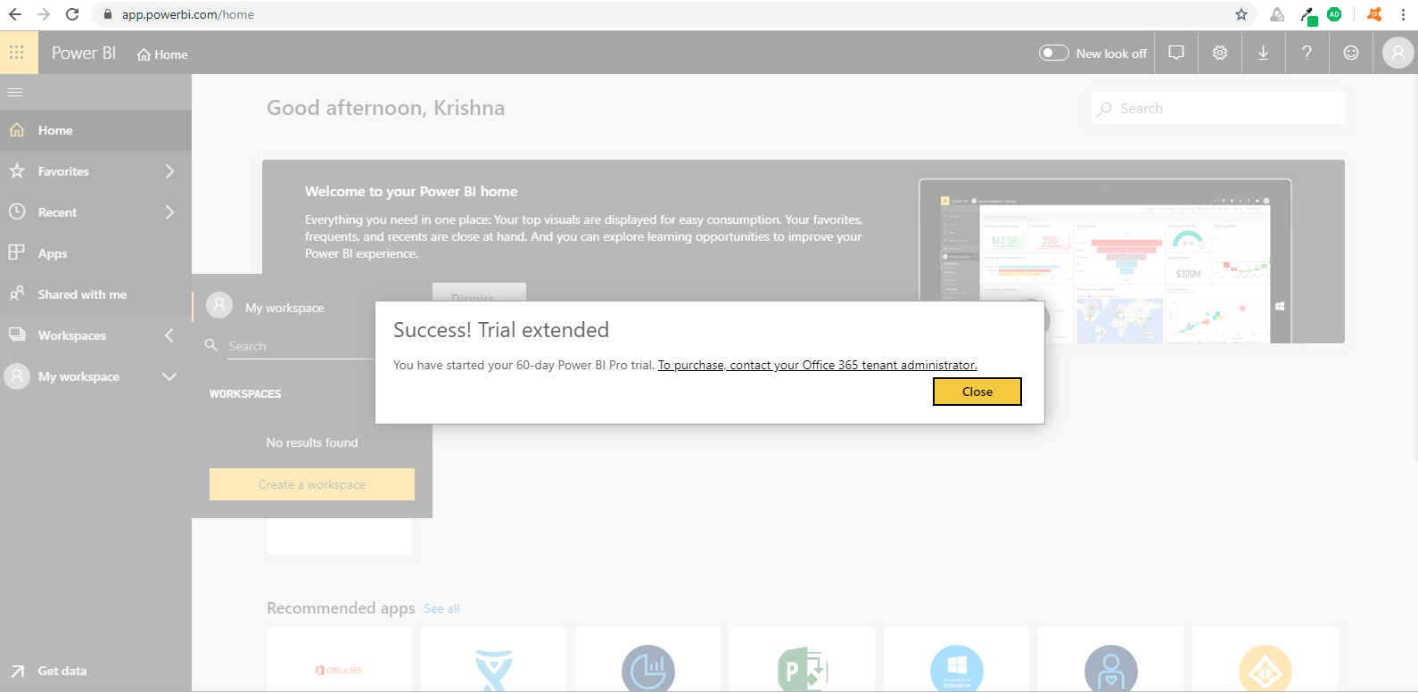

Click on “**To purchase contact your Office 365 tenant administrator**” from the above window

## Purchase and assign Power BI Pro licenses

Power BI Pro is an individual license that allows access to all content and capabilities in the Power BI service, including the ability to share content and collaborate with other Pro users. Only Pro users can publish content to app workspaces, share dashboards, and subscribe to dashboards and reports. For more information, see [Power BI features by license type](https://docs.microsoft.com/en-us/power-bi/service-features-license-type).

This article first explains how to purchase Power BI Pro licenses in Office 365. The article then explains the two options you have for assigning those licenses to individual users: Office 365 and Azure (choose one option).

## Prerequisites

You must be a member of the [**Global administrator** or **Billing administrator**](https://support.office.com/article/about-office-365-admin-roles-da585eea-f576-4f55-a1e0-87090b6aaa9d) role in Office 365.

To assign licenses in Azure, you must be an owner of the Azure subscription that Power BI uses for Active Directory lookups.

## Purchase licenses in Office 365

Follow these steps to purchase Power BI Pro licenses:

1. Open the [Microsoft 365 admin center](https://portal.office.com/adminportal/home#/homepage).
2. On the left navigation pane, select **Billing** > **Subscriptions**.

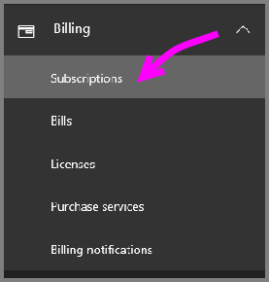

1. In the upper right corner of the **Subscriptions** page, select **Add subscriptions**.

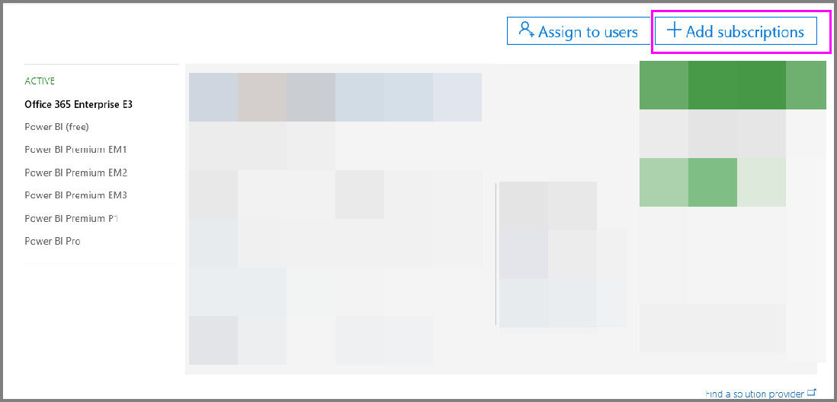

1. Locate the desired subscription offering:

Under **Enterprise Suite**, select **Office 365 Enterprise E5**.

Under **Other Plans**, select **Power BI Pro**.

1. Hover over the ellipsis (**. . .**) for the desired subscription, and select **Buy now**.

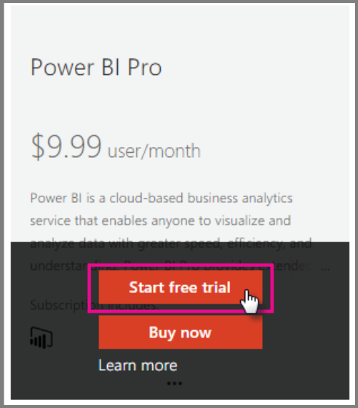

1. Choose **Pay monthly** or **Pay for a full year**, according to your billing preference.
2. Under **How many users do you want?** enter the desired number of licenses, and then select **Check out now** to complete the transaction.
3. Verify that the acquired subscription is now listed on the **Subscriptions** page.
4. To add more licenses after the initial purchase, select **Power BI Pro** from the **Subscriptions** page, and then select **Add/Remove licenses**.

## Assign licenses in Office 365

Follow these steps to assign Power BI Pro licenses to individual user accounts:

1. Open the [Microsoft 365 admin center](https://portal.office.com/adminportal/home#/homepage).
2. On the left navigation pane, expand **Users**, and then select **Active users**.
3. Select a user, then under **Product licenses** select **Edit**.
4. Under **Power BI Pro**, toggle the setting to **On**, then select **Save**.
5. Under **Status** for the selected account, verify that the Power BI Pro license has been assigned successfully.

## Assign licenses in Azure

Follow these steps to assign Power BI Pro licenses to individual user accounts:

1. Open the [Azure portal](https://ms.portal.azure.com/#@microsoft.onmicrosoft.com/dashboard/private/39bc3cf7-31a4-43f6-954c-f2d69ca2f0).
2. In the left navigation bar, select **Azure Active Directory**.
3. Under **Azure Active Directory**, select **Licenses**.
4. Under **Licenses**, select **All products** then select **Power BI Pro** to display the list of licensed users.
5. Select **Assign** to add a Power BI Pro license to an additional user account.

Once you got Power BI Subscription , you can access Power Bi Desktop features like Create Work Spaces and publish reports into Power BI Services.

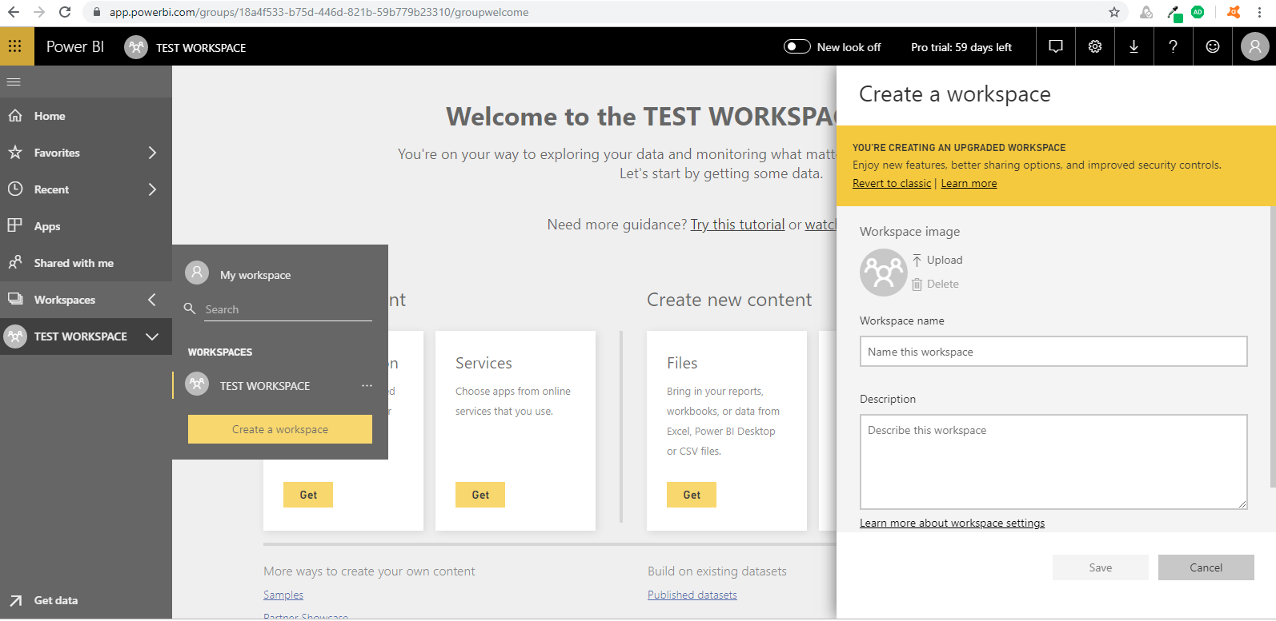

After you have an account, enter app.powerbi.com in your browser to open the Power BI service.

## Get Power BI Desktop

**Power BI Desktop** lets you build advanced queries, models, and reports that visualize data. With **Power BI Desktop**, you can build data models, create reports, and share your work by publishing to the Power BI service. **Power BI Desktop** is a free download.

You can download the latest version of Power BI Desktop from the following download page:

* [**Power BI Desktop download** (both 32-bit and 64-bit versions)](https://powerbi.microsoft.com/desktop).

## Using Power BI Desktop

When you launch **Power BI Desktop**, a Welcome screen is displayed.

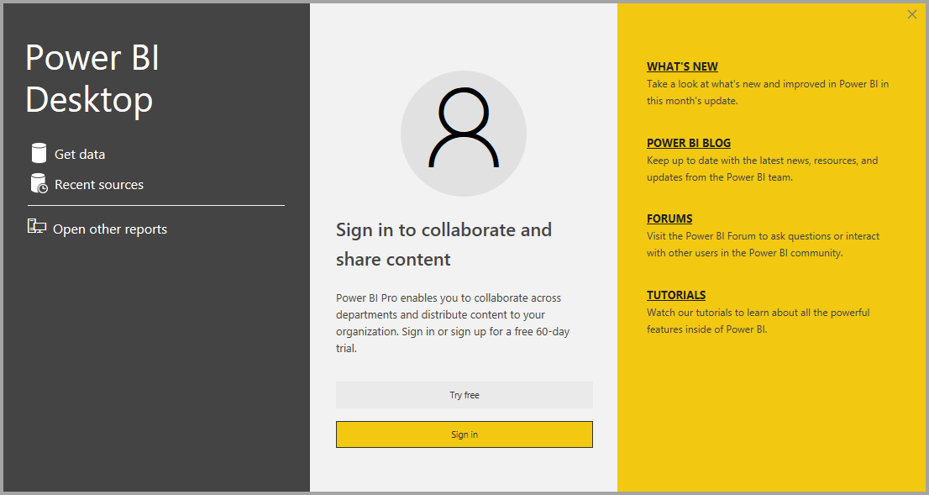

If this is your first-time using **Power BI Desktop** (if the installation is not an upgrade), you'll be prompted to fill out a form and answer a few questions, or sign in to the **Power BI service** before you'll be able to proceed.

From there, you can begin creating data models or reports, then share them with others on the Power BI service.

## Minimum requirements

The following list provides the minimum requirements to run **Power BI Desktop**:

* Windows 7 / Windows Server 2008 R2, or later
* .NET 4.5
* Internet Explorer 10 or later
* **Memory (RAM):** At least 1 GB available, 1.5 GB or more recommended.
* **Display:** At least 1440x900 or 1600x900 (16:9) recommended. Lower resolutions such as 1024x768 or 1280x800 are not recommended, as certain controls (such as closing the startup screen) display beyond those resolutions.
* **Windows Display settings:** If your display settings are set to change the size of text, apps, and other items to more than 100%, you may not be able to see certain dialogs that must be closed or responded to in order to proceed using **Power BI Desktop**. If you encounter this issue, check your **Display settings** by going to **Settings > System > Display** in Windows, and use the slider to return display settings to 100%.
* **CPU:** 1 gigahertz (GHz) or faster x86- or x64-bit processor recommended.